Policy
Pitch

Xianglong Ronaldo Lin (45791439)

Qiao Zhang (47785076)

Ziruo Zhu (47803390)

Economics for Business ECON1011

Topic, Scope, and Perspective

This policy brief will introduce a suggestion about the Australian rental crisis. This suggestion will indicate how to avoid the Australian rental crisis, so that it can make more people able to afford or obtain rental housing. Overall, this proposal will show the opinion that the government helps people from low-economic backgrounds in Australia.

Proposed Policy

This proposal will alleviate the rental crisis in Australia and remove some troublesome obstructions. The Australian rental crisis is becoming increasingly serious, the cheap rental housing is getting fewer and fewer (Anderson, 2023). The implementation of rent controls and subsidies can ease the Australian rental crisis. The rental subsidies can help people to pay partial rent, it allows them to have more time to keep their current house. Therefore, the Queensland government has proposed "Rental Security Subsidy can help Queenslanders who are faced with short-term financial barriers which make it difficult to pay the rent and sustain a tenancy in the private rental market" (Queensland government, 2022, para. 1). The rental controls not only can keep the rents from going up substantially, but there is also a new model. "Dr Martin, who specialises in rental housing affordability and tenancy law, suggested a model where rent could increase but would be tied to the Consumer Price Index" (Gately, 2022, para 14-15). In general, the rent controls and subsidies can be used by the Australian government to get more people from low-economic backgrounds to stop worrying about the rent.

Economic Analysis

Government provision of subsidies would be a more common and effective solution. Assuming that the government provides subsidies to rental intermediaries or landlords themselves in the same amount as the blue portion of the square footage, the supply curve S1 shifts to the right to S2 and creates a new equilibrium E2. The equilibrium then rests at the point where more listings are available at lower prices. Output and competitiveness increase rapidly as capital increases, providing smaller companies that are more affordable and have good listings can get a foothold in the market faster. Meanwhile, governments can provide subsidies to lower income groups to reduce inequality. Only when more people are able and willing to support renting affordable housing will they be able to grow faster with the government and address externalities.

Price limits are also a good method often used by governments to limit from two completely opposite sides. The maximum price is set below the equilibrium price to encourage people to rent. In this case, the government needs to set the maximum price for real estate agents and landlords in order to protect or encourage low-income groups to buy. In contrast, the minimum price is set above the equilibrium price level. This would yield more stable prices and reduce the number of landlords refusing to offer properties because they are unhappy with the price.
Both have some limitations. The short duration of their actions is also an unavoidable drawback. Due to surpluses and shortages, market forces will act like an invisible hand after a while to pull or push prices back to the original equilibrium price.

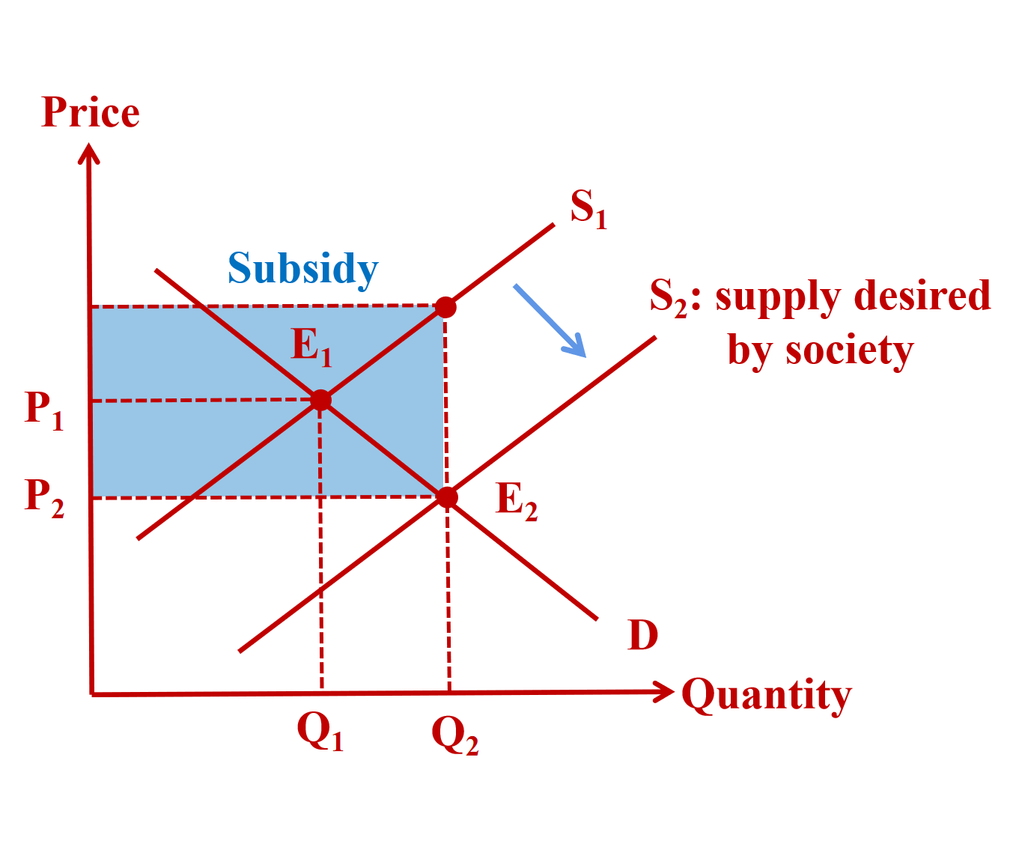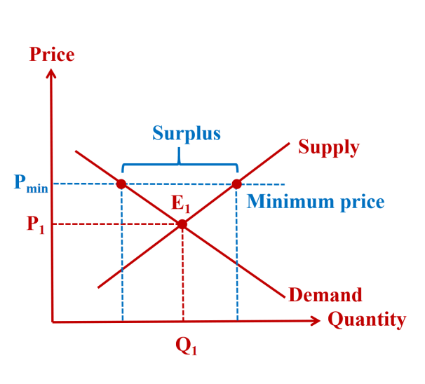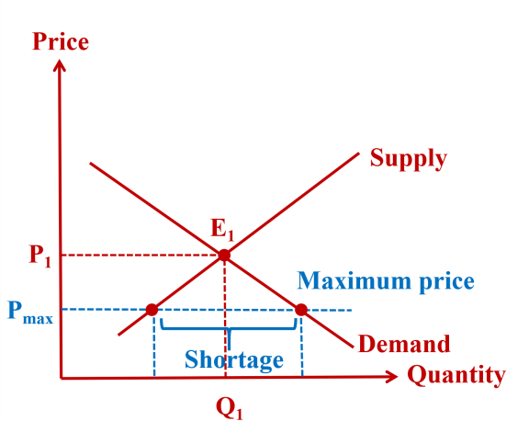

Cost-benefit Argument

One of the main benefits of implementing the rent controls and subsidies in Australia is the increased accessibility and affordability. The research by Beer et al. (2014) shows that the policies can help the Australian government reduce the financial burden of the vulnerable populations, including the people from the low socio-economic background, by making the Australian rental housing more accessible and more affordable. Therefore, the rate of the homelessness can be reduced in Australia. The easier access to affordable housing also provides greater stability for the tenants in Australia, as the rent controls prevent the sudden and excessive rent increases, allowing the tenants to better plan for the future housing expenses, which is a significant issue in the major cities like Sydney and Melbourne (Yates & Milligan, 2007). Finally, providing the tax credits for the landlords who rent to the eligible tenants by the Australian government could encourage the affordable housing for the people from the low socio-economic background, thereby increasing the availability of the overall affordable rental units in Australia.

However, there are the potential costs associated with the rent controls and subsidies in Australia. For example, the rent controls may prevent the owners from renting the properties, resulting in the reduction in the overall supply of the rental houses in Australia. Furthermore, Pawson et al. (2015) note that the implementation schemes of the rent control and subsidies in Australia would require the additional government resources, thereby increasing the administrative costs. Finally, strict rent controls may hinder the investment in the Australian housing market, as the property owners may consider the lower potential return on the investment.

To overcome the potential obstacles and weaknesses in the Australian rental crisis, the balanced approach to the rent controls should be adopted. This includes striking the balance between protecting the tenants and protecting the interests of the landlords, which helps to minimise the potential negative impacts on the property supply and investment within the Australian market. And focusing the subsidies on the most vulnerable populations that includes the people from the low socio-economic background could ensure that the policy effectively meets the needs of those who need the assistance, while minimising the total costs. Finally, the regular monitoring of the impact of the rent controls and subsidies on the housing market and making the necessary adjustments can ensure that the Australian policy remains in effect and is adapted to the changing market conditions.

References (APA)

Anderson, A. (2023, March 7). Report shows fewer cheap rentals across Australian Capital Cities. news.com.au. https://www.news.com.au/finance/real-estate/renting/report-shows-fewer-cheap-rentals-across-australian-capital-cities/news-story/6b4acbacfc79b32ebf37cb742d6c0393

Beer, A., Bentley, R., Baker, E., Mason, K., Mallett, S., Kavanagh, A., & LaMontagne, T. (2014). Addressing homelessness amongst persons with a disability: identifying and enacting best practice.

AHURI Final Report No. 224. Melbourne: Australian Housing and Urban Research Institute.
Gately, M. (2022, March 16). Could rent control ease the housing crisis? here are the arguments for and against. ABC News. Retrieved May 4, 2023, from https://www.abc.net.au/news/2022-03-17/could-rent-control-help-to-ease-australia-s-housing-crisis/100908288

Pawson, H., Milligan, V., & Yates, J. (2015). Assessing recent developments in Australian housing policy. International Journal of Housing Policy, 15(3), 337-355.

Queensland government. (2022, December 22). Rental security subsidy. Queensland Government. https://www.qld.gov.au/housing/renting/rent-assistance/financial/security-subsidy

Yates, J., & Milligan, V. (2007). Housing affordability: A 21st-century problem. AHURI Final Report No. 105. Melbourne: Australian Housing and Urban Research Institute.

